
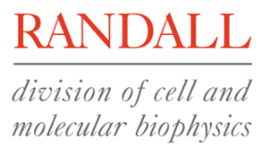




ASSENT FORM FOR YOUNG PEOPLE
AGED 5-15 YEARS

Muscle connective tissue in limb development and disease
Version 1.3,
19/11/2015

Young person to circle all they agree with please:

Have you read (or had read to you) about this project? Yes No

Has somebody else explained this project to you? Yes No

Do you understand what this project is about? Yes No

Have you asked all the questions you want? Yes No

Have you had your questions answered in a way you understand? Yes No

Do you understand it’s OK to stop taking part at any time Yes No

Are you happy to take part?  

If any answers are ‘no’ or you don’t want to take part, don’t sign your name.

If you do want to take part, please write your name and today’s date.

Name of Child (PRINT)…………………………… Date of Birth...........................

Signature…………………………………………….. Date…………………………...

Name of Mother* (PRINT)…………………………………………………………………..

Signature…………………………………………….. Date…………………………...

Name of Father* (PRINT)…………………………………………………………………..

Signature…………………………………………….. Date…………………………...

Name of Guardian(s) (PRINT)…………………………………………………………………..

Signature…………………………………………….. Date…………………………...

Name of person obtaining consent (PRINT)…………………………………………………………………..

Signature…………………………………………….. Date…………………………...

*Only one of the parents has to sign the form to validate it, but if parents wish to they can both sign.

When completed: a copy of this form will be returned to you. The original will be sent back to the limb development study team together with your sample(s).

