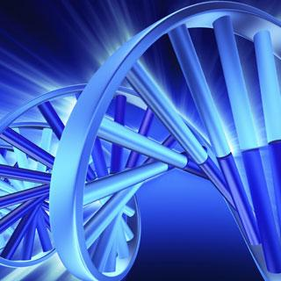
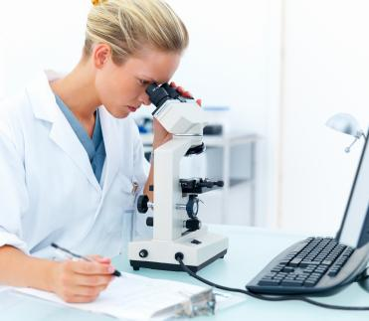
PATIENT INFORMATION LEAFLET
FOR YOUNG PEOPLE 11-15 YRS

Muscle connective tissue in limb development and disease
Version 1.3 19/11/2015

Sometimes children are born with changes to their limbs. Scientists, doctors and nurses work with young people and their close family to understand why this happens. We want to learn more about how our limbs develop, and how this sometimes happens differently. Your arm and hand are made up of different types of tissue, such as skin, muscle and fat. The more we understand about these tissues, how they are shaped in the first place, and how they grow, the more chance we have of making people better.

We would like to invite you to take part in our research. Before you decide if you would like to help please read this information sheet and talk to your mum / dad / the person who looks after you. You can also talk to your doctor or nurse if you want to. The leaflet explains why we are asking you to help and what it will involve for you. Thank you for reading this.

Why are we doing this research?
We would like to find out more about normal limb development, and the changes that happen in a condition called radial dysplasia, where part of the forearm and hand don’t develop properly. We hope this will help us to offer better treatment to children and young people with this condition. In order to do this, we need both young people with radial dysplasia and young people having surgery for other reasons to let us take small tissue samples during their operation.

Why have I been asked to take part?
We are recruiting young people who are having surgery to their hand or forearm as part of their treatment. We need young people like you to help us get a better understanding of how our limbs develop.

Do I have to take part?
No, taking part is up to you. It’s OK if you don’t want to take part and won’t change any medical care you receive.

What will I be asked to do if I take part?
- Your doctor or nurse or member of the study team will ask you and your parents to sign a form, giving your ‘assent’ (permission) and your parents ‘consent’ (permission).
- You will be given a copy of this information leaflet and your signed form to keep.
- We will collect information about your medical and family history, now and in the future. This information will be taken from the records that your doctors and nurses keep of your medical care and treatments.
- During your operation, when you are asleep, your surgeon will collect 1-3 small tissue samples, and give these to the research team. If your operation normally involves removing any tissue, and it would normally be destroyed, your surgeon may decide to give that to the research team too. The rest of your operation will be the same as usual.

Will I notice anything different after the operation?
No, things should be the same after the operation whether you volunteer to help or not. Your scar will be the same size, and your hand and forearm should not be any more painful than normal after your operation. You will have the same dressings, the same hand therapy, and the same visits to the doctor either way.

Will anyone else know I’m helping?
In addition to your own doctors, other doctors and nurses in the research team will look at the information we collect. No one else apart from you, your family and our doctors and nurses will know you’re taking part. Your sample will be labelled with a special number while the scientists study it- it won’t be labelled with your name. The scientists looking at the samples in the laboratory will not know who they were given by. We will let your GP (family doctor) know you are helping us, unless you or your parents ask us not to.

What will happen to any samples I give?
We will bring your tissue sample into the laboratory and run a large number of different tests. Samples obtained from your tissue will be stored for use in further research.

What are the possible benefits of taking part?
Taking part may not help you, but we hope that the information we could get from studying any sample you give and looking at your health records will help provide better treatment for other children and adults in the future.

What will happen next?
In the future we will write or email you to let you know the overall results of our study, and to thank you for taking part.

What if I don’t want to take part anymore?
It’s OK if you decide to help us and then change your mind. You can stop taking part at any time and you don’t have to say why. You just tell one of the nurses, doctors or ask your mum, dad or the person who looks after you to let us know. You can still keep coming to the hospital or the GP surgery to see the doctors and nurses if you need their care.

Thank you for reading this – please ask any questions if you need to.

