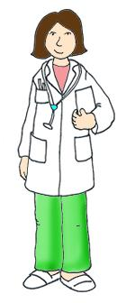
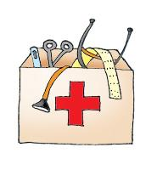
Patient Information sheet
for Children 5 – 10 yrs

Muscle connective tissue in limb development and disease
Version 1.4 26/01/2016

Please read this carefully. There may be words you do not understand. Ask your doctor or nurse or parents if you do not understand something. Thank you for reading this.

Sometimes children are born with a hand or arm that is different. The doctors and nurses who look after you and your family, work with scientists to learn more about how our hands and arms develop, and how this sometimes happens differently. Your arm and hand are made up of different types of tissue, such as skin, muscle and fat. The more we understand about these tissues, and how they grow, the more chance we have of making people better.

Why me?
We are asking many boys and girls who are having surgery on their hand or arm.

What will I have to do?
Helping involves giving us a small amount (‘a sample’) of your tissue during your operation, when you are asleep. Scientists will then study the sample to learn more about how your hand and arm are made. The surgeon will do your operation the same way as normal. If you agree, during the surgery, they will also take some small tissue samples. After the operation, you won’t be able to tell the samples were taken. You will get better from the operation in the same way whether you give a sample or not.

Do I have to join?
No, taking part by giving a sample of your tissue is up to you. It’s ok if you don’t want to take part.

Will anyone else know I’m doing this?
No one else apart from you, your family and our doctors and nurses will know you’re taking part.
If you decide to help then your sample will be given a special number before it is used by scientists. The scientists who will look at your sample will not know who you are.

What if I don’t want to take part anymore?
It’s OK if you decide to help us and then change your mind. You can stop taking part at any time and you don’t have to say why. You just tell one of the nurses, doctors or ask your mum, dad or the person who looks after you to let us know. You can still keep coming to the hospital or the GP surgery to see the doctors and nurses if you need their care.

If I decide ‘yes’ - what next?
If you decide ‘yes’ then you will be asked to sign a form. Your mum or dad will also have to sign a form. This means that they allow you to take part.

Thank you for reading this – please ask any questions if you need to.

